**World Port Index**

**About Dataset**

The World Port Index (Pub 150) contains the location and physical characteristics of, and the facilities and services offered by major ports and terminals world-wide. Entries are numbered geographically. In 2020, NGA undertook an effort to modernize the content and delivery of the World Port Index, resulting in additional and enhanced data fields, and a web application viewing platform. The modernization also implemented crowd-sourcing methods to validate and update the content.

GitHub: <https://github.com/Dnshusngh/SQL-word.port_index/blob/e472b4b86eb12d21a8947c892a217d007c02a8ae/word%20port%20index%20sql>

[SQL-word.port_index/word port index sql at main · Dnshusngh/SQL-word.port_index (github.com)](https://github.com/Dnshusngh/SQL-word.port_index/blob/main/word%20port%20index%20sql)

LinkedIn: <https://www.linkedin.com/pulse/world-port-index-dipanshu-singh-fenaf>

Kaggle: <https://www.kaggle.com/datasets/rajkumarpandey02/world-wide-port-index-data>

Created By: Dipanshu Kumar Singh

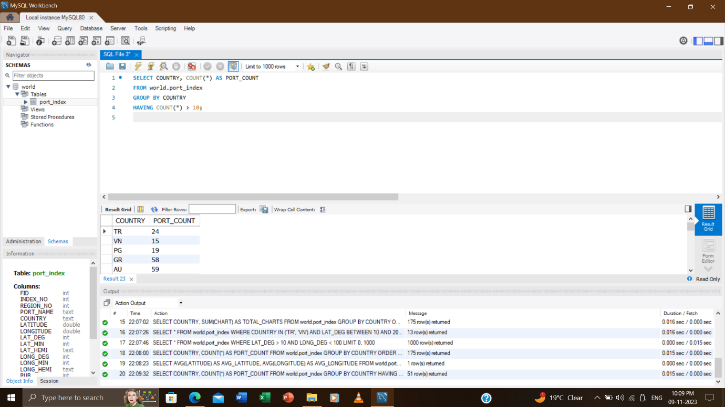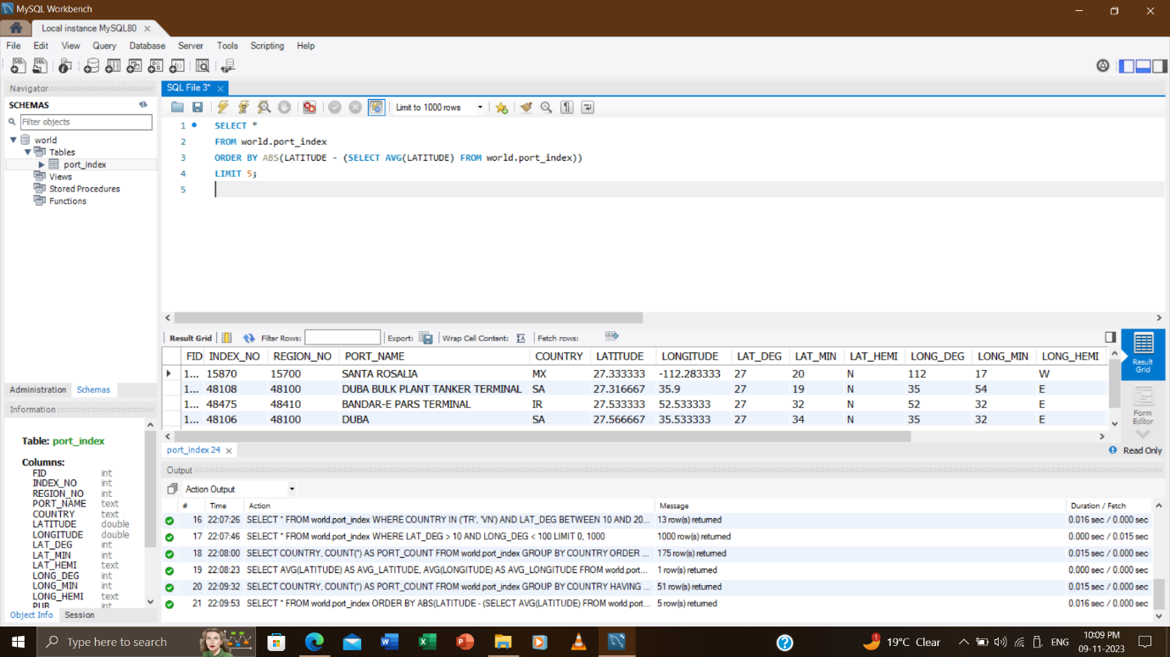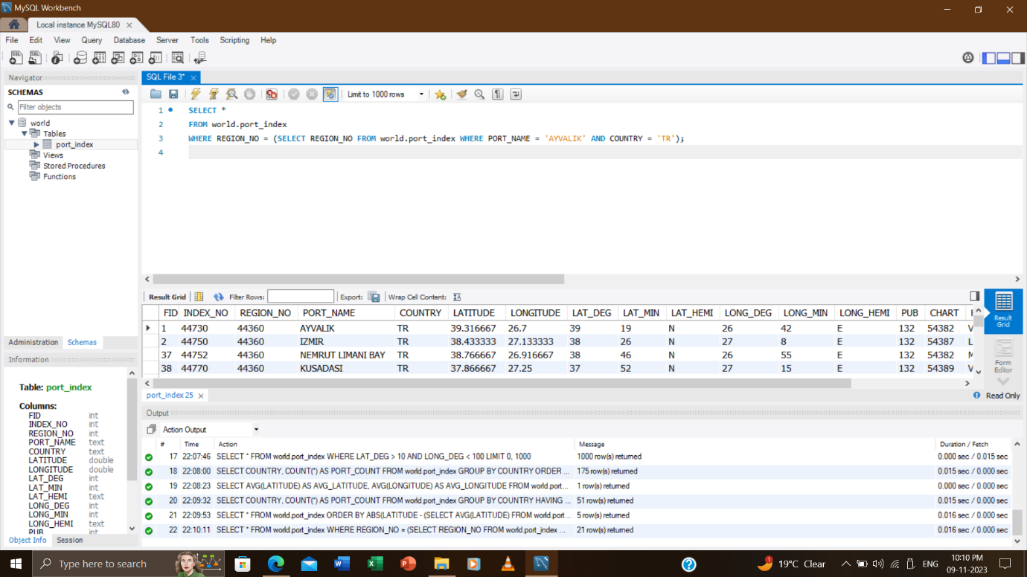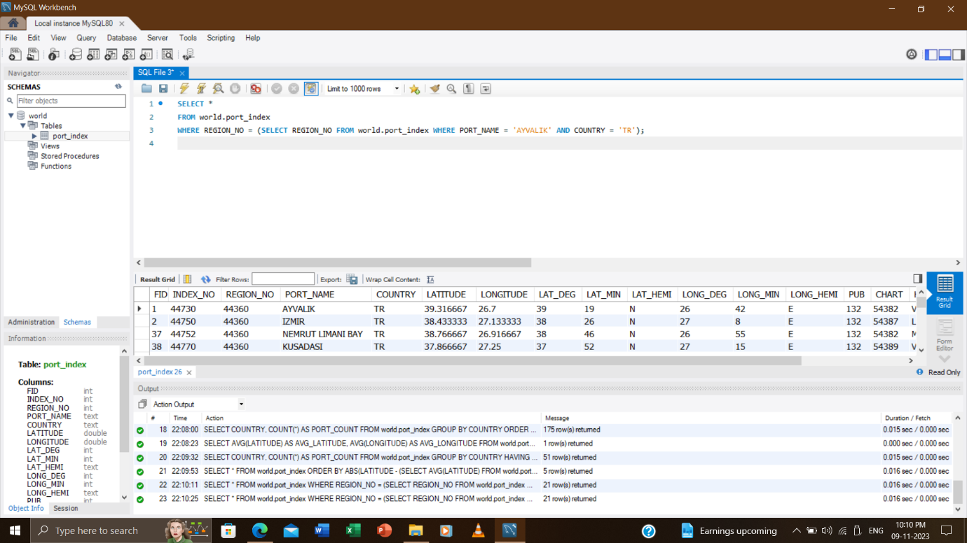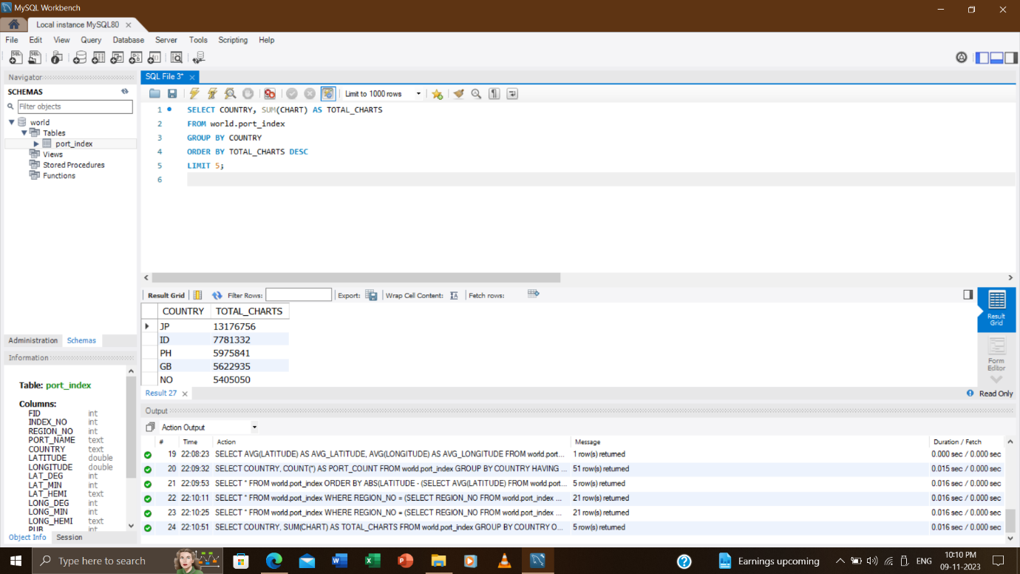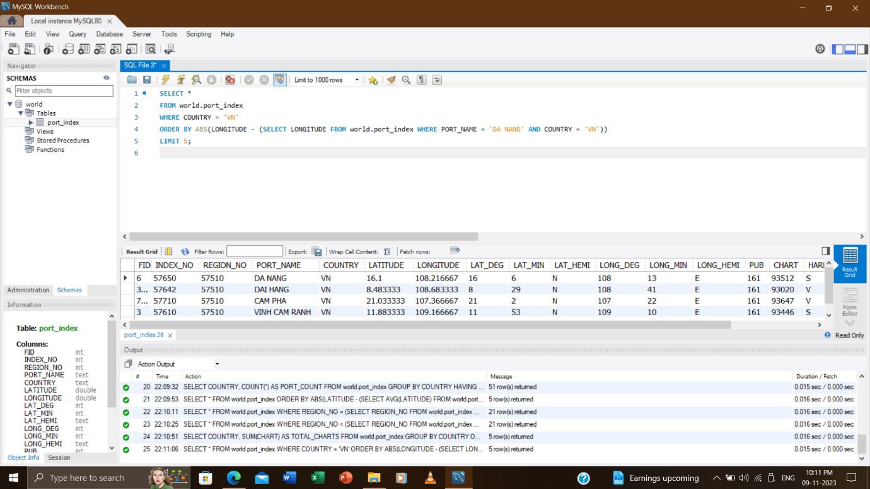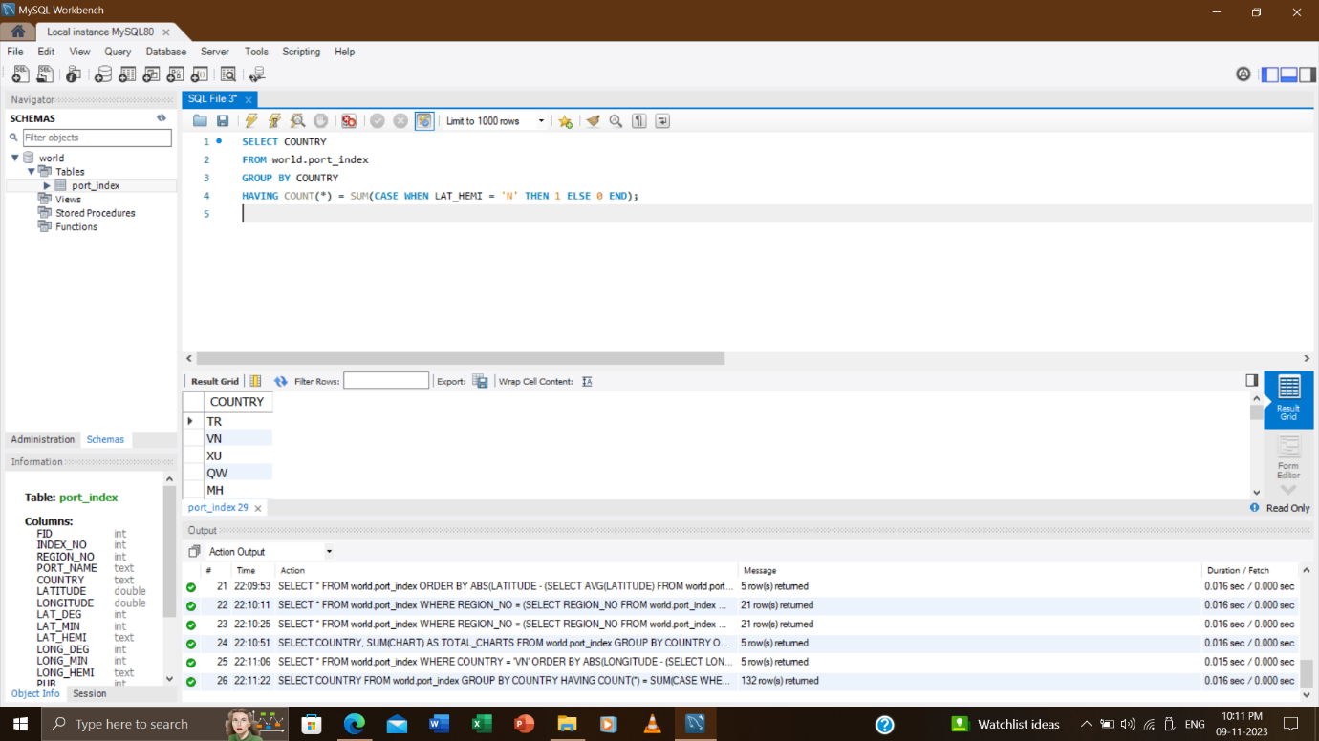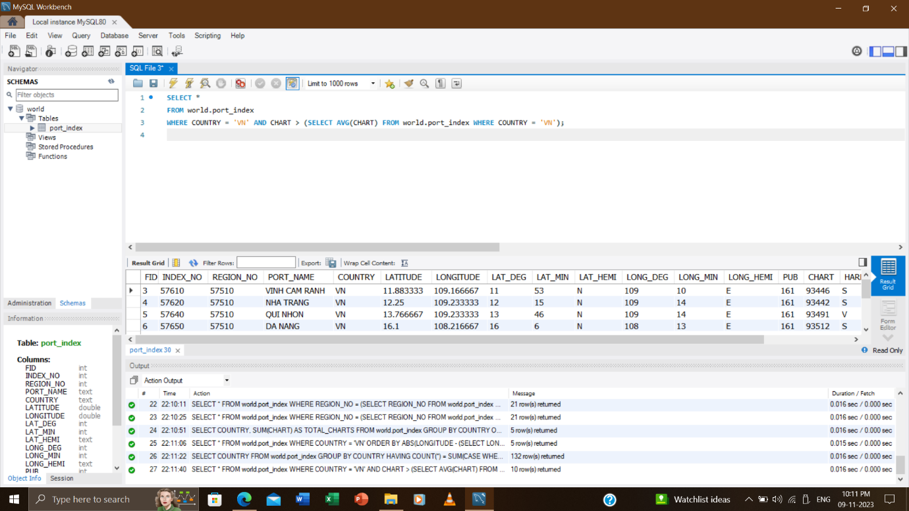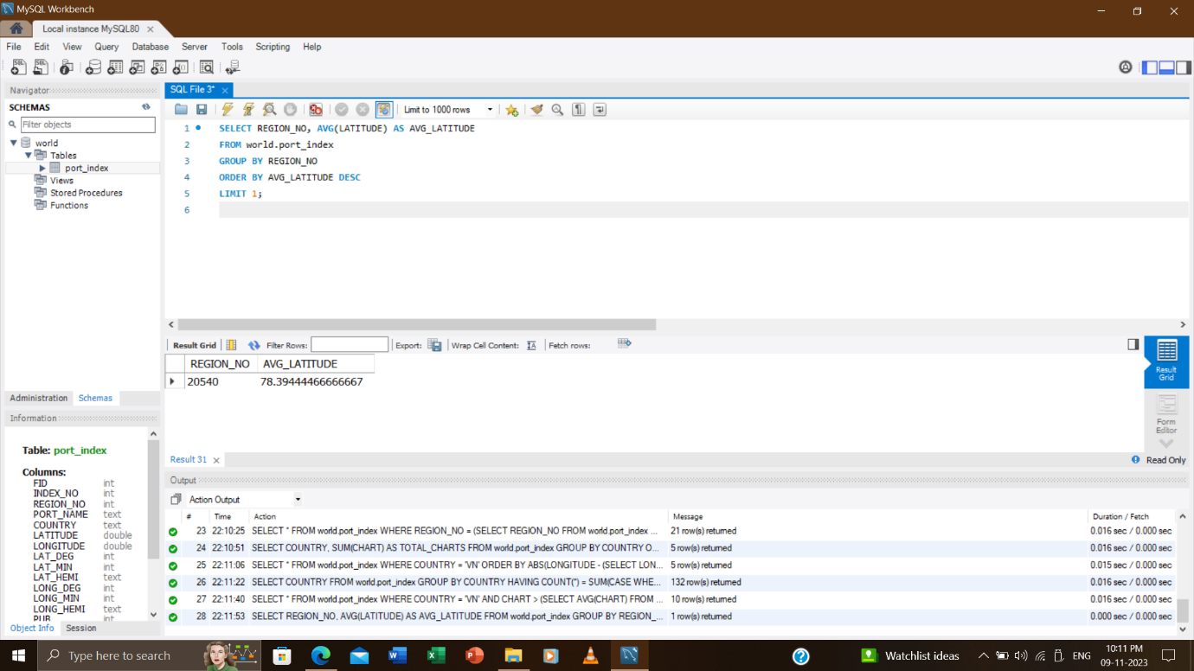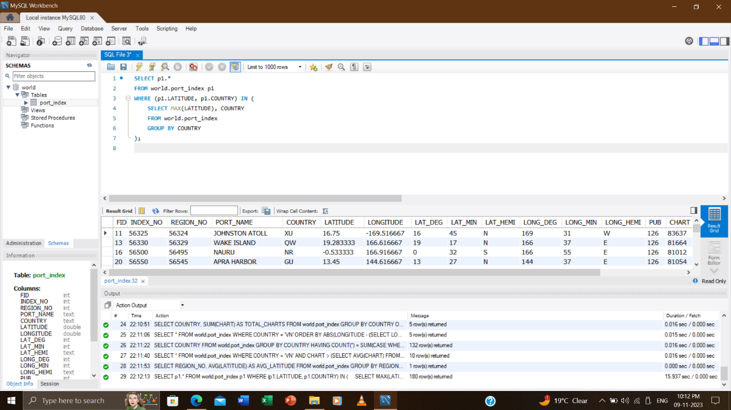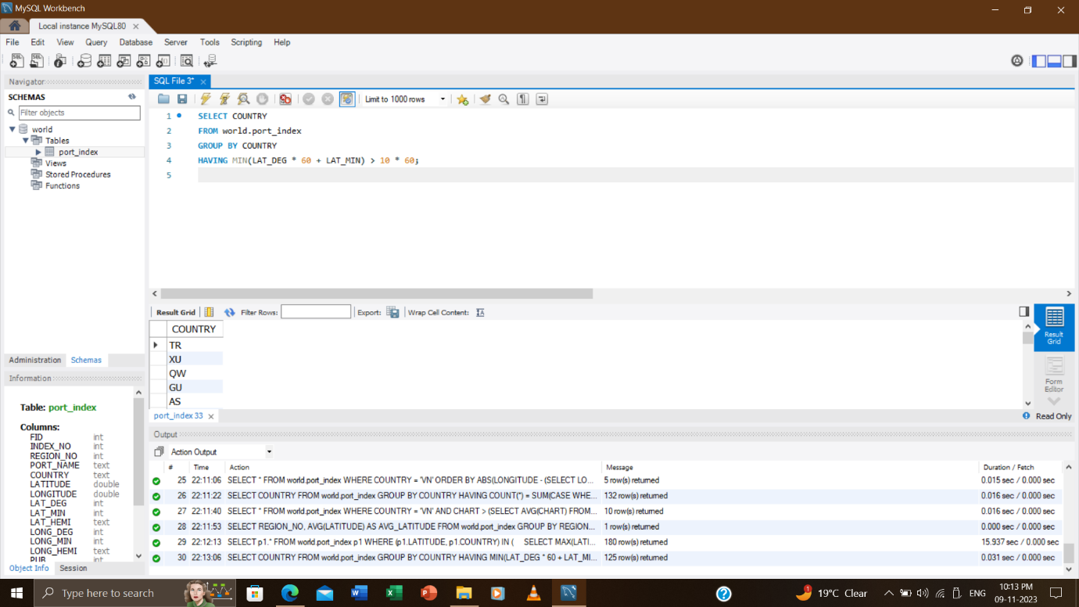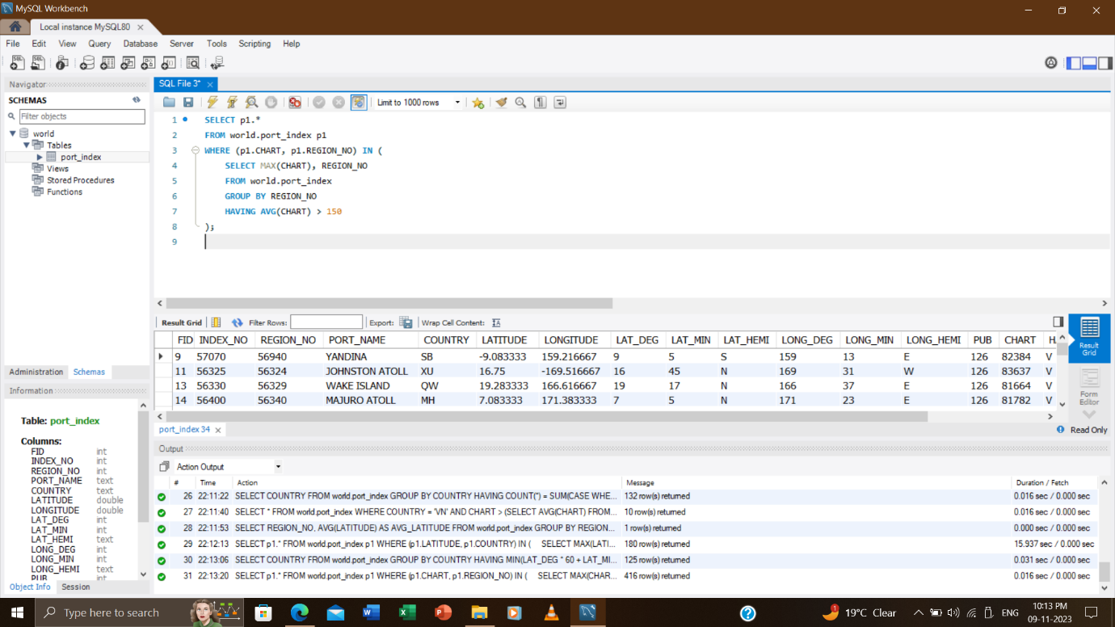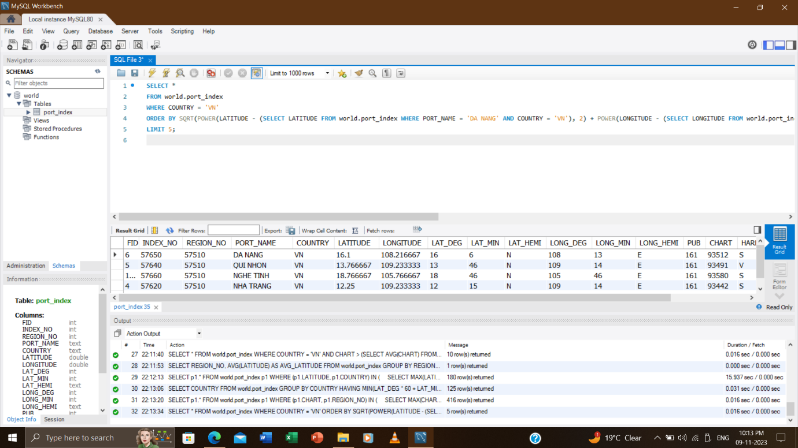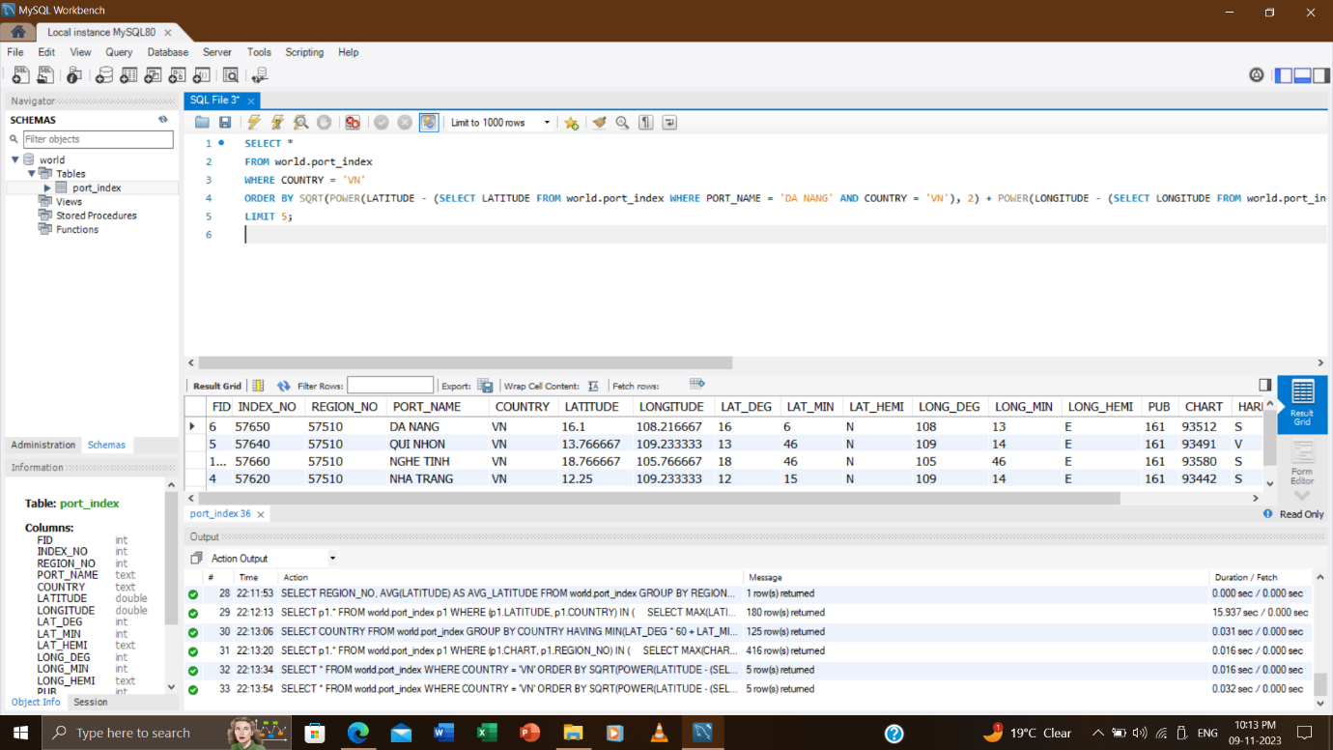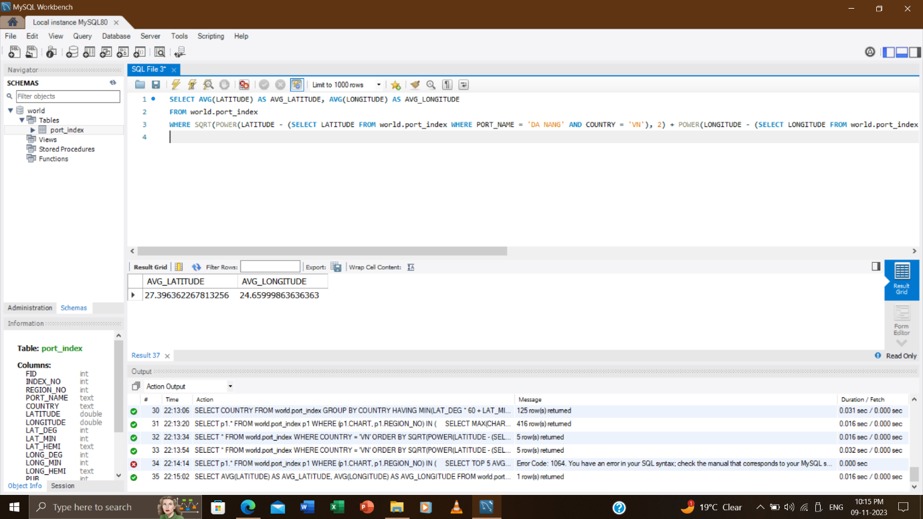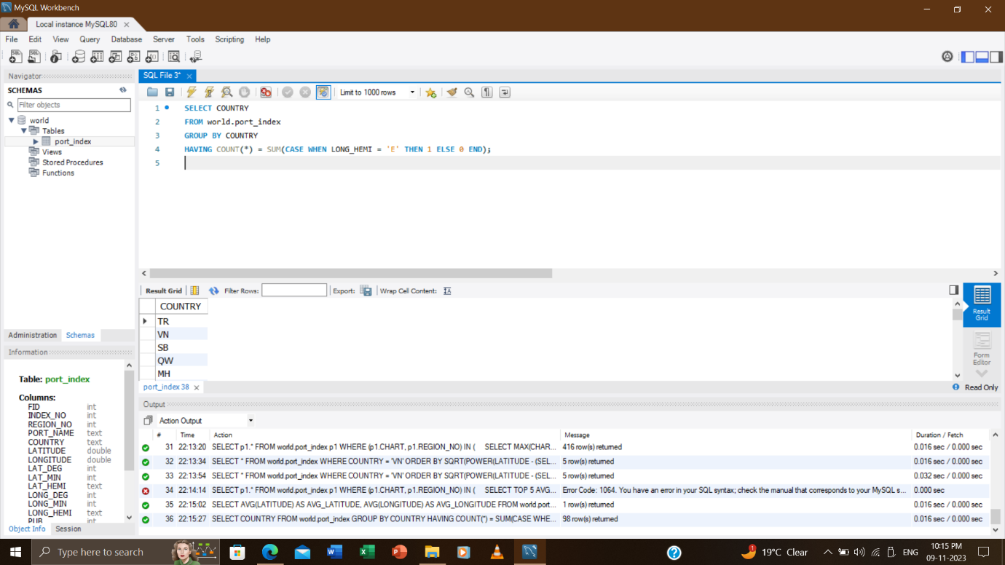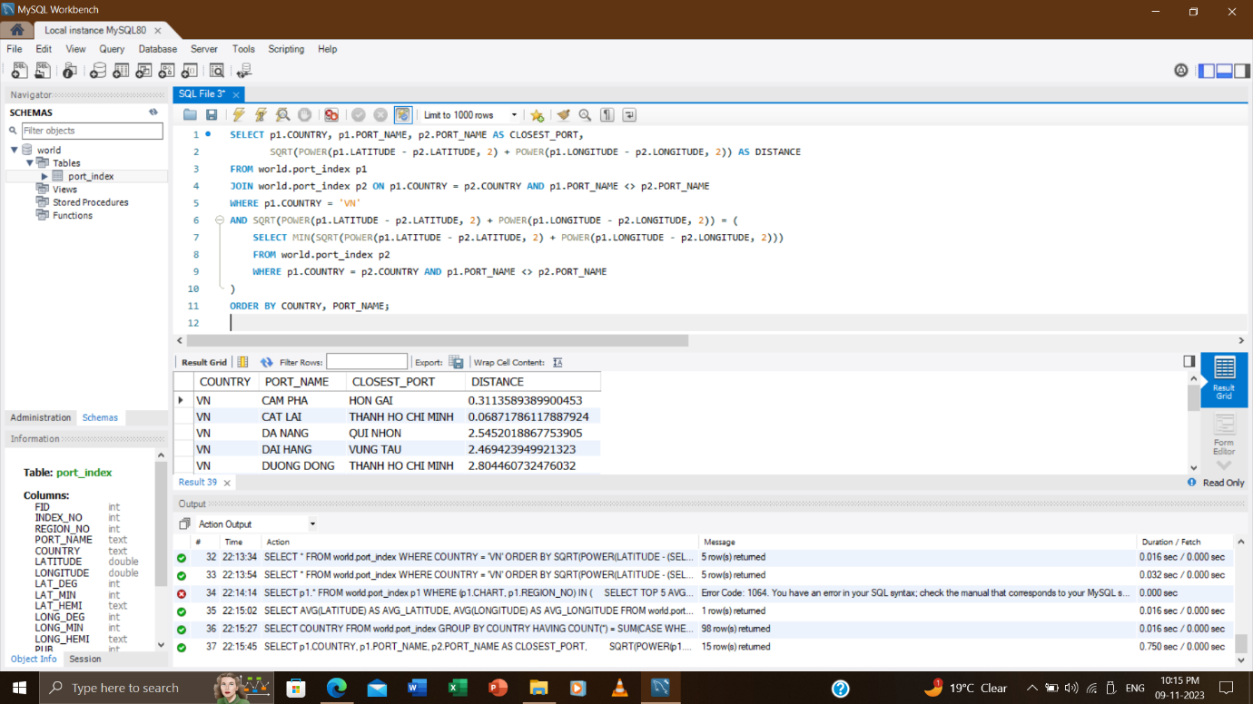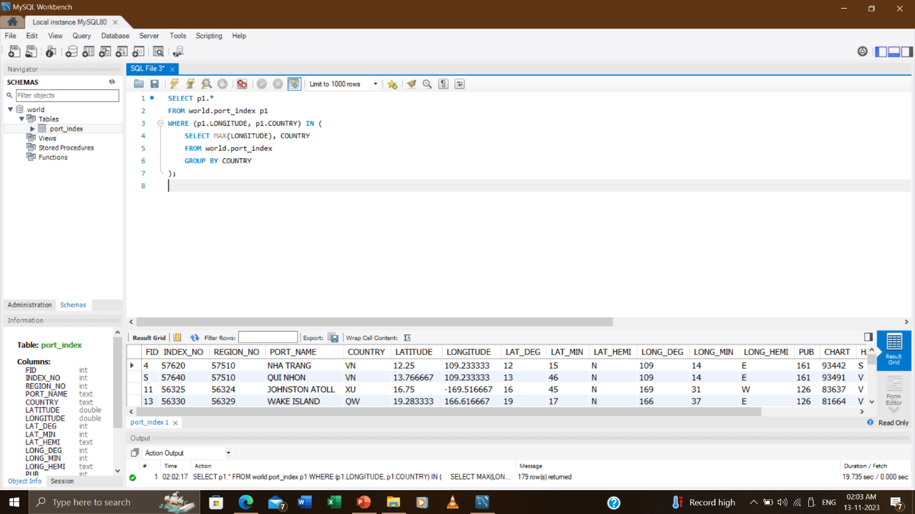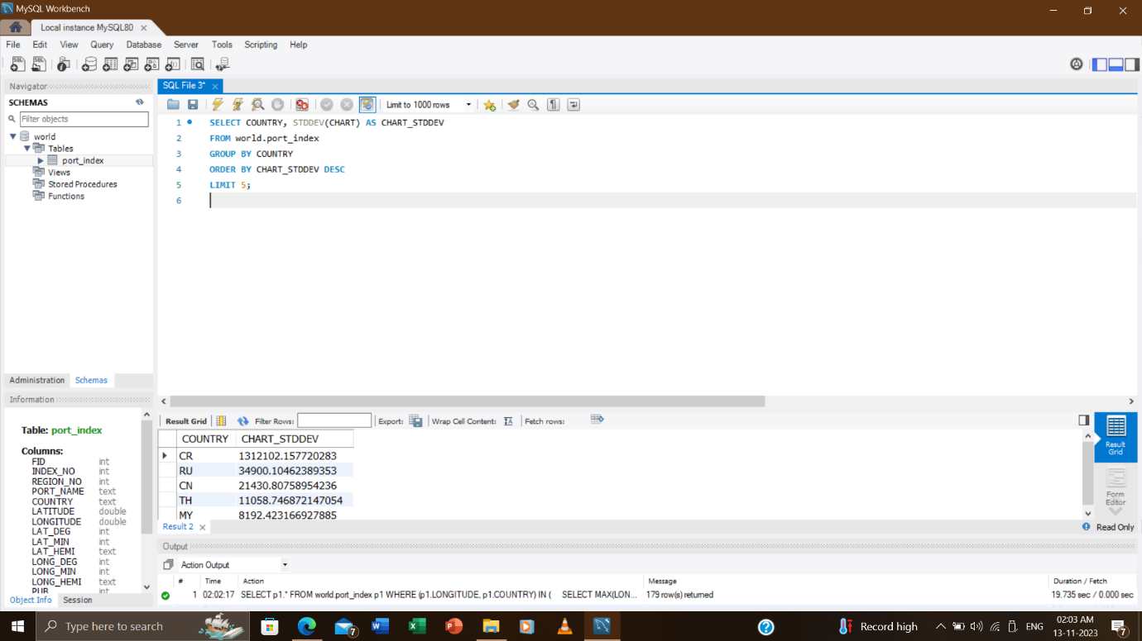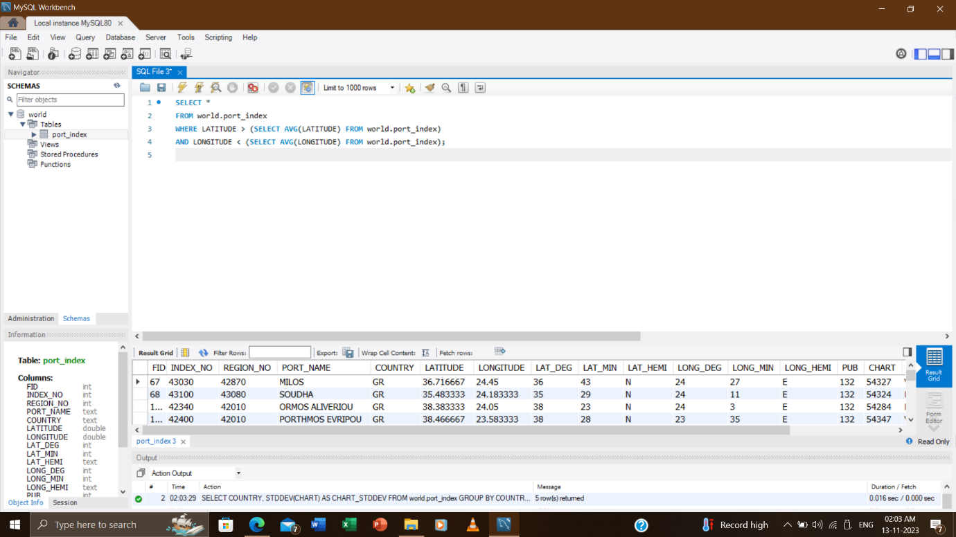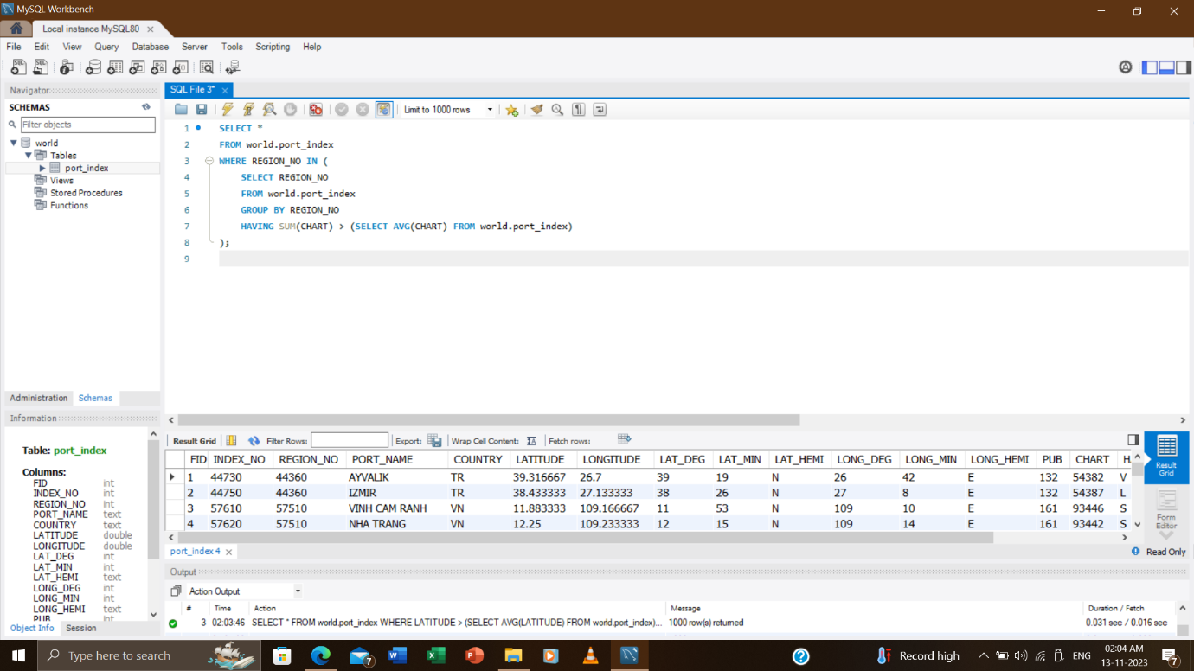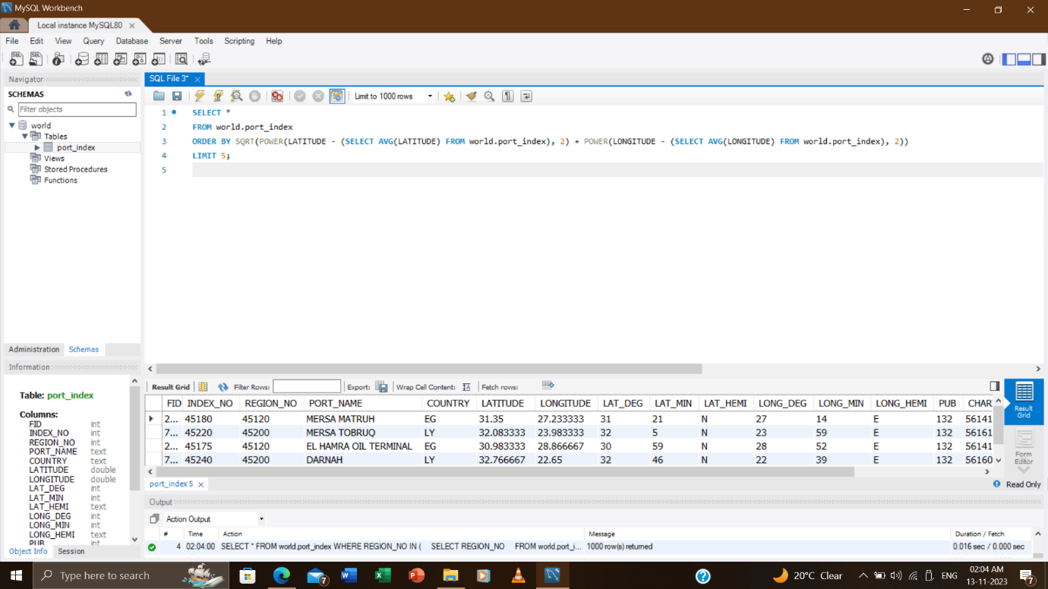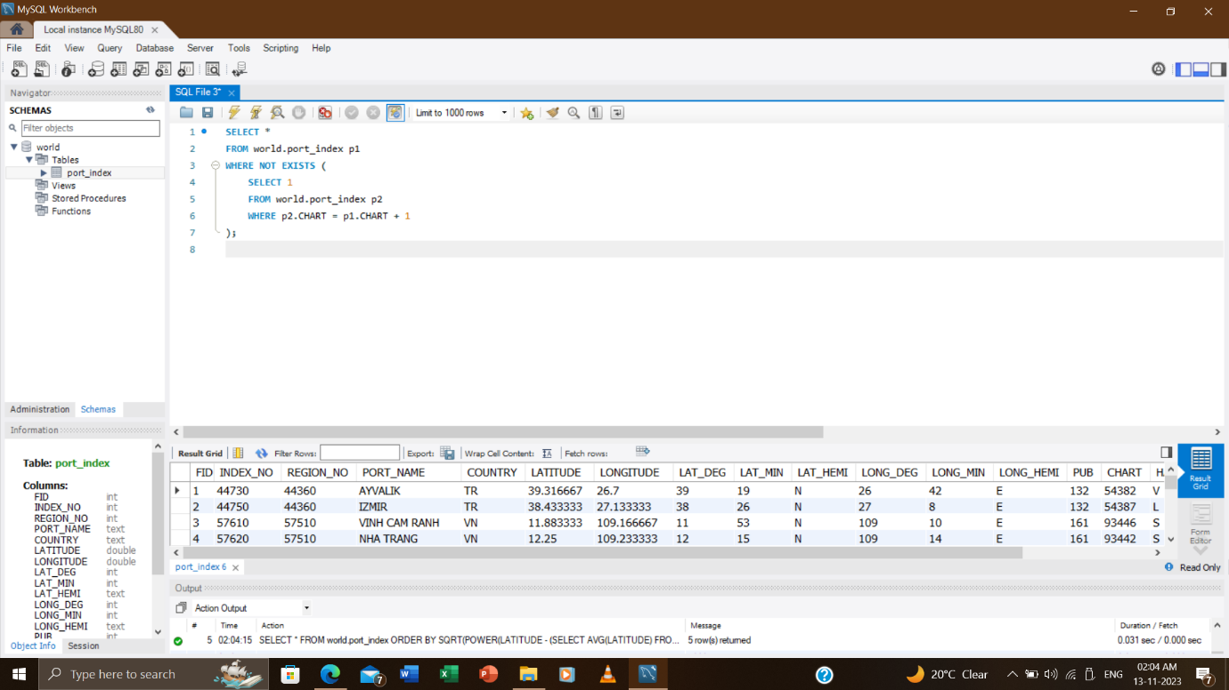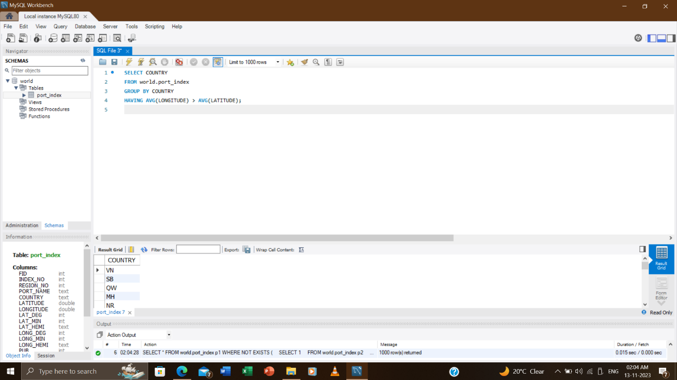

Thank you.